8th June 2018

**YOKOHAMA Debuts in the Italian Prototypes Championship**

Last weekend saw the first race of the “Campionato Italiano Sport Prototipi” – Italian Prototype Championship, held in Monza. 2 x 25 minutes races plus a last lap with inverted grid in the second race which delighted the large number of spectators witnessing the races.

Yokohama Italy, supplied ADVAN A005 slick tyres to the 20 cars in the grid. (Wolf’s GB08 Thunder by Wolf Racing Cars)

Race 1 was won by Lorenzo Pegoraro, who was in top form and also scored valuable points in Race 2. Also on the podium Hùlten and Capitanio followed in Race 1 while Riccitelli and Pollini also made the podium in Race 2.

For the first time YOKOHAMA is supporting this Championship and will supply the tyres for the next 5 years. “I’m really glad to work with Wolf Racing Car for the Italian Prototypes Sport Championship,” – said a delighted Giuseppe Pezzaioli, Yokohama Italy’s Motorsport Manager – “Our slick products guaranteed high-end performance on this track, and really tests the carcass of the tyre for the stress that it has to endure in the fast turns, like the famous Curva Parabolica.”

The next races of the “Campionato Italiano Sport Prototipi” will be held in Mugello on 16th July 2018, in Imola at the end of July and after a break in August it will start again in Vallelunga in the first half of September. Then Mugello will host the final race at the end of October.

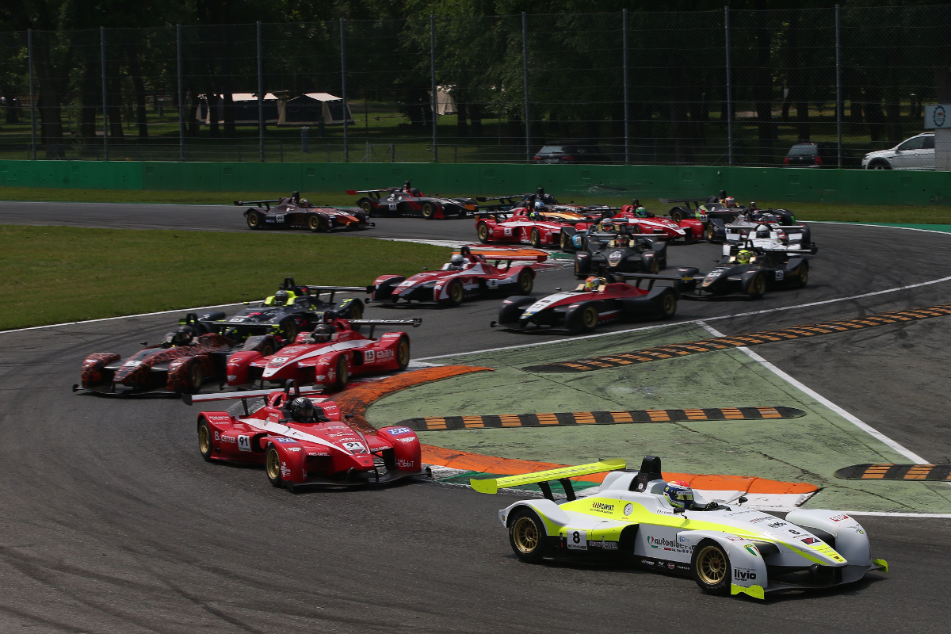

*Gara Monza 1*

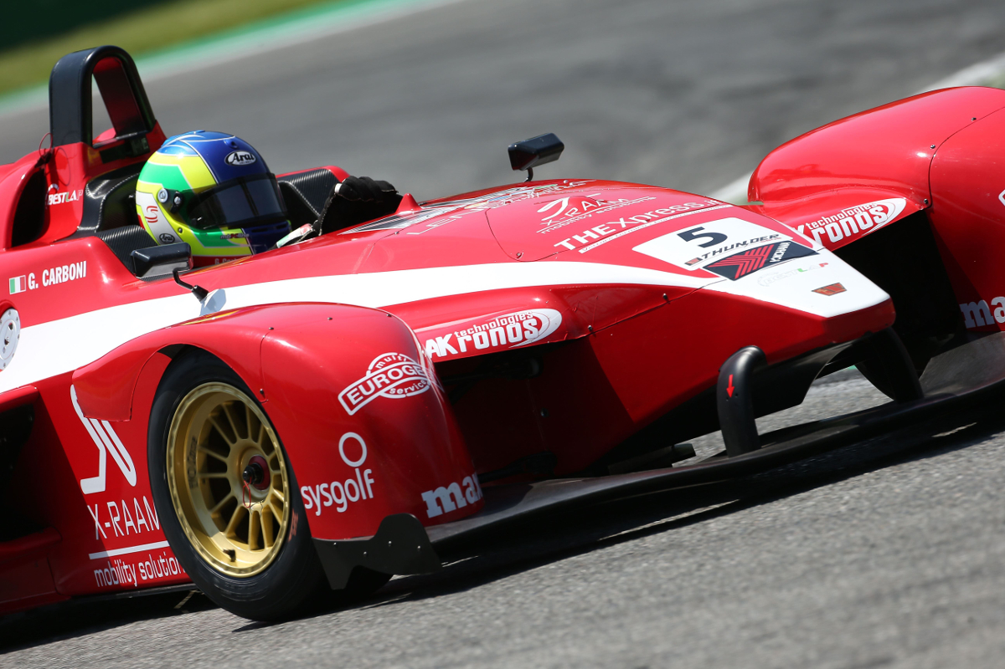

*Gara Monza 2*